Good afternoon,
Dr. Solek visited the Materials and Manufacturing Summer Teachers’ Institute session held at Eli Whitney today, in conjunction with Southern Connecticut State University. Dr. Solek met with industry leaders, State Representative David Yaccarino, and our own teacher leaders! Dave Tuttle, Precision Machining Department Head presented on Manufacturing today. Greg AmEnde, Interim Precision Machining Department Head at Eli Whitney presented on CNC work, Sterling Engine, and using the plasma cutter. The focus was for teachers to be able to bring projects back to their schools, apply practical mathematics and demonstrate aspects of manufacturing as a recruitment tool for workforce development.

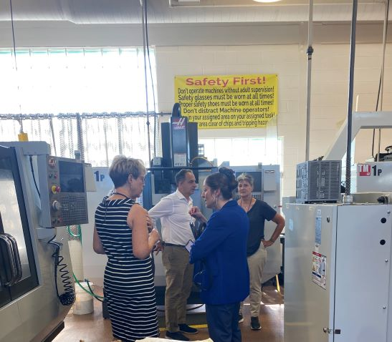
Dr. Solek discussing Manufacturing programming.

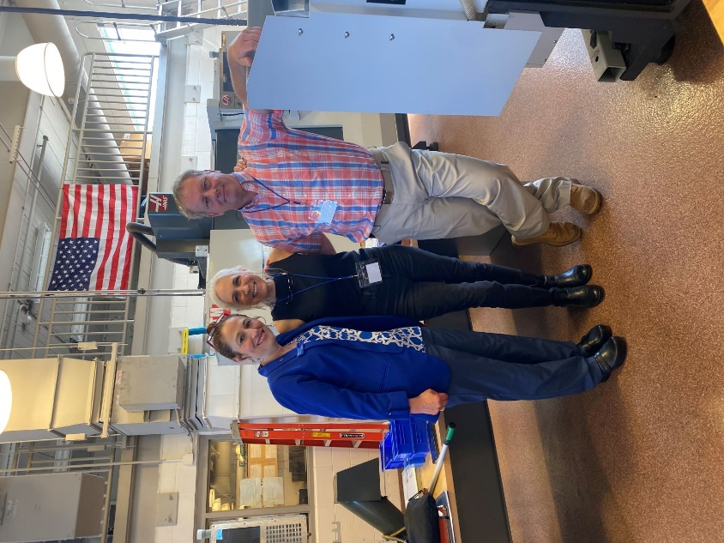
Dr. Christin Broadbridge-SCSU, Kathy Saint-President Schwerdtle Mfg., Dave Tuttle-Platt Tech Precision Machine Department head
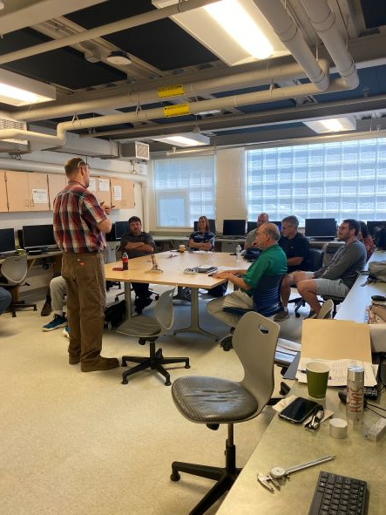
Mr. AmEnde instructing the class.

