3/10/23  
Good afternoon Eli Family,  
 As I write this, we have another weather event that may occur. We will keep spring thoughts alive and be safe with the potential snow event.

* We have a scheduled day off for students on 3/15/23 as we have a District Professional development day.
* Congratulations to Mrs. Sumowski for being nominated the Teacher of the Year. We thank and appreciate all of her hard work to make Eli Whitney a better place through her instruction and collegiality. Some of Mrs. Sumowski’s credits are her supervision of the Owl Gazette, our first student-run newsletter and community-driven activities, and creating hats for children at Yale children’s hospital.
* The juniors will be taking the SAT assessment on March 22nd. We have been preparing students for the SAT. It is important that we all encourage our students to do the best they can on test day. The test is not only used for college entrance but for the school standing and graduation. We will be planning an event for the students such as a special breakfast for positive participation.
* If your student has been absent from school when submitting a note, please send them/direct to Mr. LeSieur, Dean of Students, [chris.lesieur@cttech.org](mailto:chris.lesieur@cttech.org) If you have medical physical paperwork, please give them to the nurse or main office. Nurse’s email, [Michelle.Inahuazo@cttech](mailto:Michelle.Inahuazo@cttech).
* The PFO meeting will be held at Eli Whitney on March 15th at 5:30 pm. Be sure to come to help support our students at Eli Whitney!
* We will be hosting a virtual internet safety presentation for parents on March 16th. The link will be forthcoming.
* The Amazing March issue of the Owl Gazette was completely run by the students. Assistant Supervisor Princess Twasam (11th) took on the reins and ran with this month's issue. Along with Lead Reporter John'ae Hart (11th) and the rest of The Gazette Team: Celia Perez (9th), Karla Reynoso (11th), and Alexander Hernandez (12th). Thank you to the OWL Gazette team and Mrs. Sumowski for her supervision!

[https://www.canva.com/design/DAFZQTDBZwI/1V7vru4SdU8rzq_Qqg8Gjg/view?utm_content=DAFZQTDBZwI&utm_campaign=designshare&utm_medium=link&utm_source=homepage_design_menu](https://nam12.safelinks.protection.outlook.com/?url=https%3A%2F%2Fwww.canva.com%2Fdesign%2FDAFZQTDBZwI%2F1V7vru4SdU8rzq_Qqg8Gjg%2Fview%3Futm_content%3DDAFZQTDBZwI%26utm_campaign%3Ddesignshare%26utm_medium%3Dlink%26utm_source%3Dhomepage_design_menu&data=05%7C01%7CJoseph.F.DiNatale%40cttech.org%7Cb2492a886a84472ae69108db1cf39eb8%7C73766ff90cce4d2cabfde5341c9f8b42%7C1%7C0%7C638135604892182284%7CUnknown%7CTWFpbGZsb3d8eyJWIjoiMC4wLjAwMDAiLCJQIjoiV2luMzIiLCJBTiI6Ik1haWwiLCJXVCI6Mn0%3D%7C3000%7C%7C%7C&sdata=5qh4LhqNb6B4zL6mj4SsjlCQg%2B%2Fv7aCbNGMNLxkfIvw%3D&reserved=0)

* On Wednesday, March 8th at 10:30 am, the IT Shop had guest speakers from Yale University to discuss employment opportunities. Assad Layne, ITS Systems Cloud Engineer - Level 2, and Tristen Lawrence; ITS Software Engineer / Systems Administrator at Yale University.
* 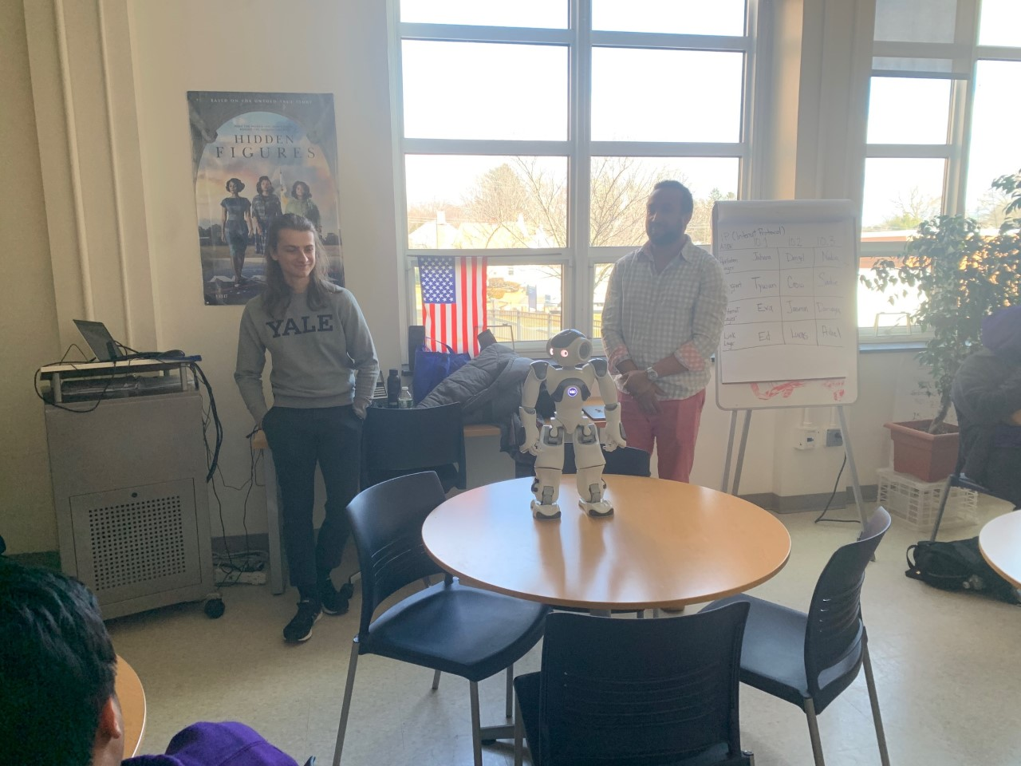
* 
* The hairdressing and barbering 11th and 12th graders went to New York City to the Javits center to visit the International Beauty Show. It was an amazing experience for everyone to learn about the latest techniques in the field! Thank you to Ms. Howarth and Mrs. DeAngelis for coordinating the trip! Ms. Correa, former Eli Whitney HBT instructor from Central office chaperoned the trip as well.
* 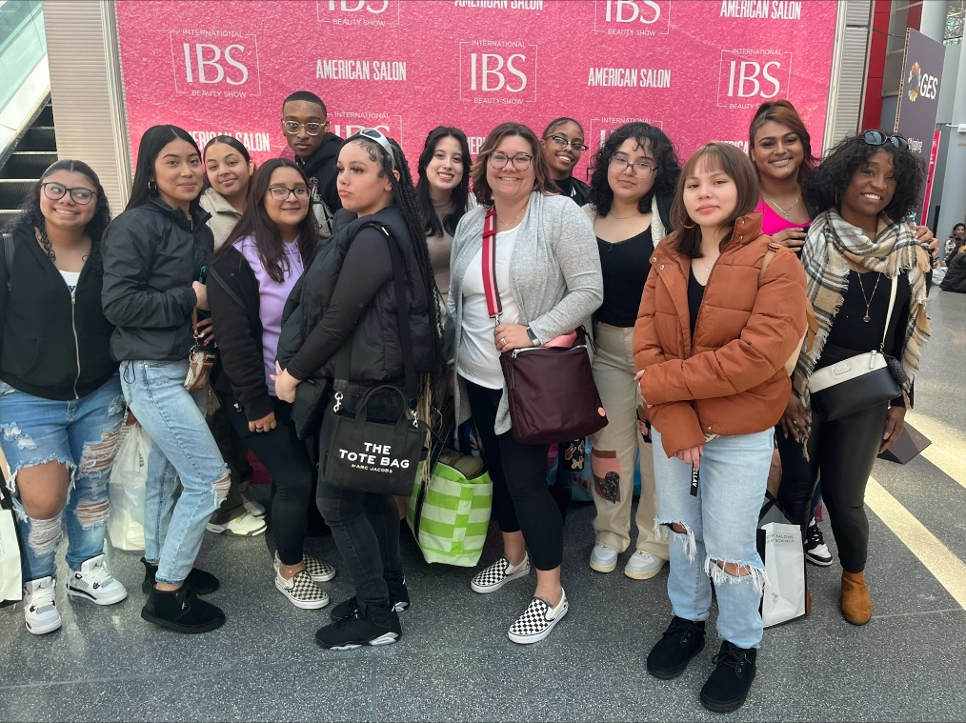
* 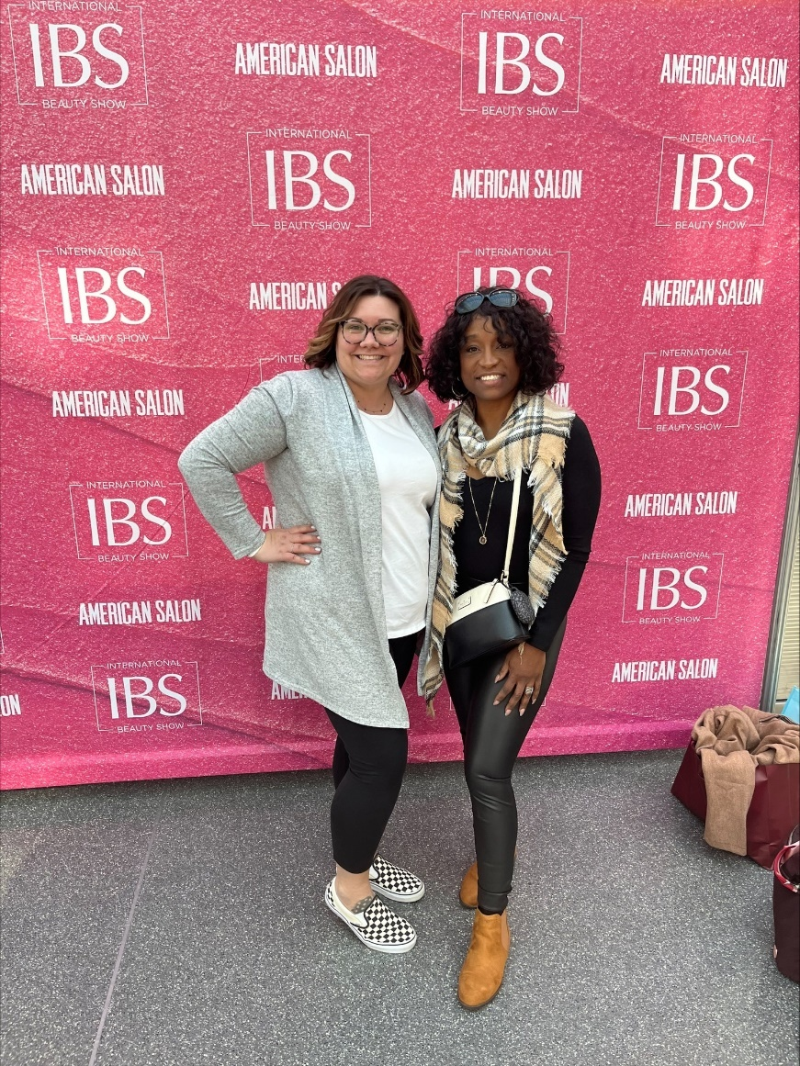
* 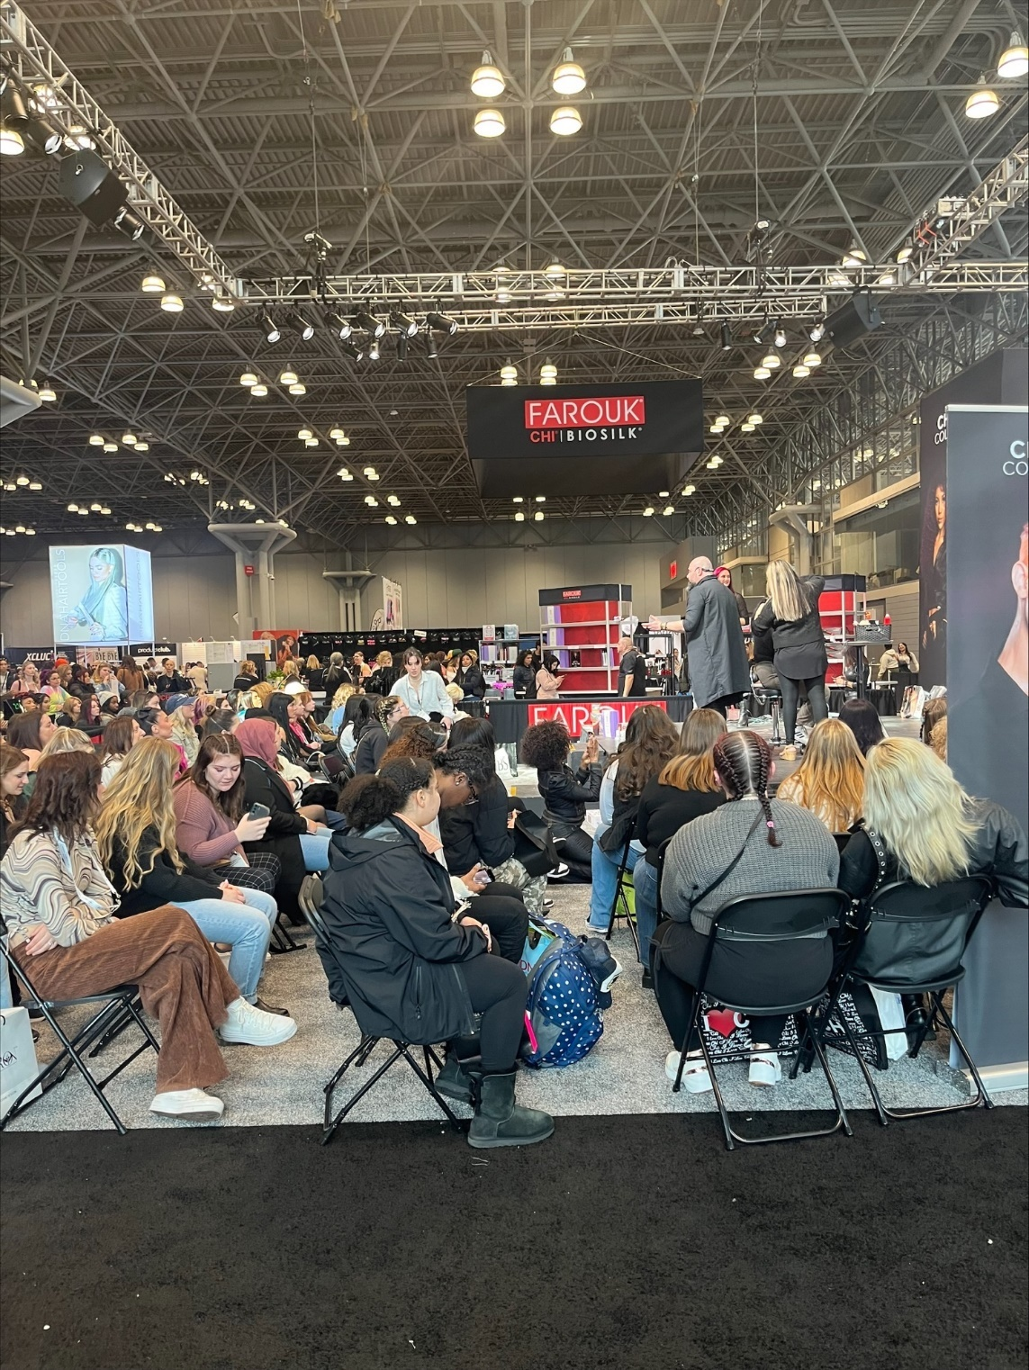
* 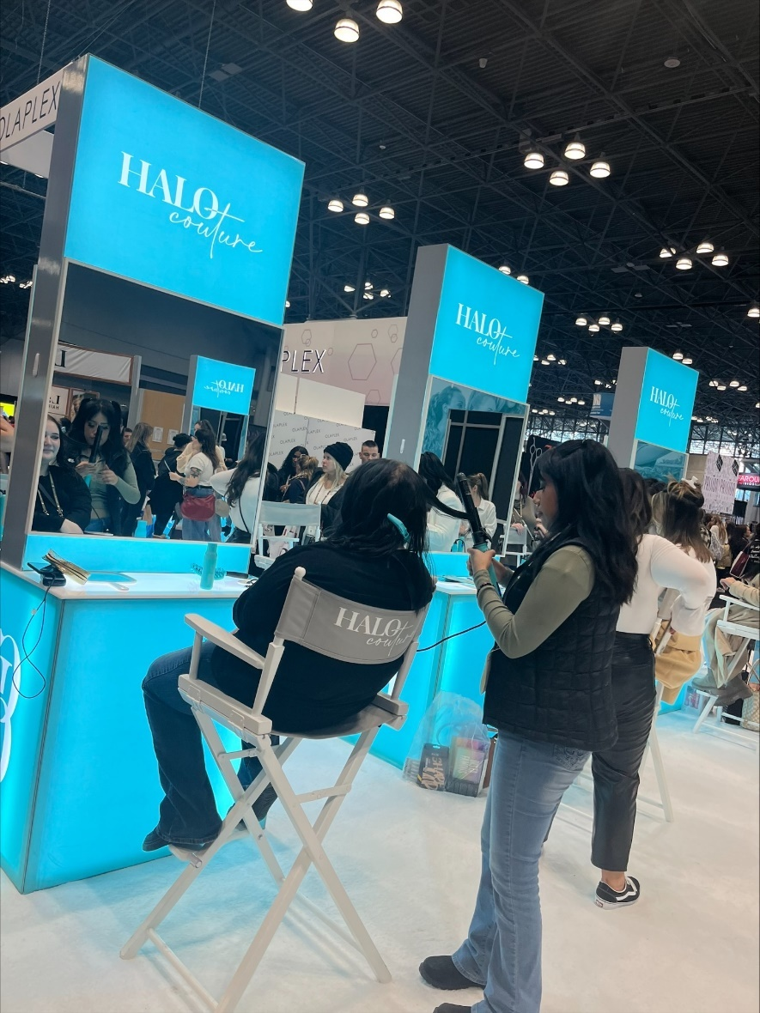
* 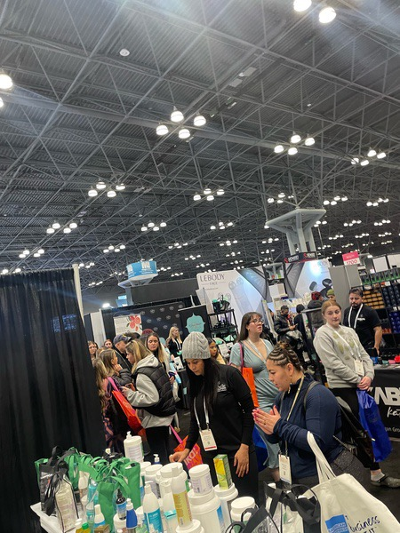
* 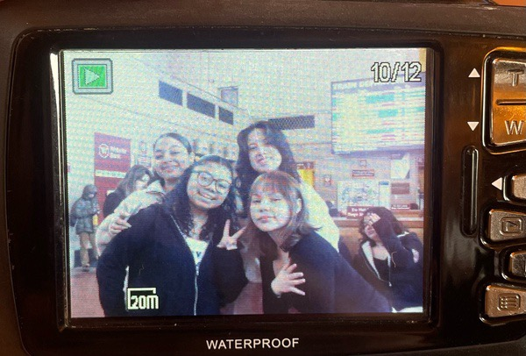
* 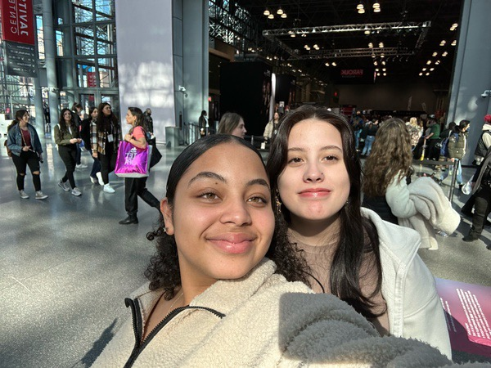
* The boys’ basketball team defeated Computer Science in the first CIAC playoff game. It was an exciting game!
* 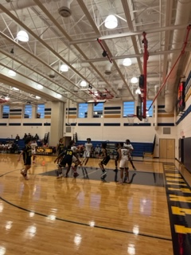
* 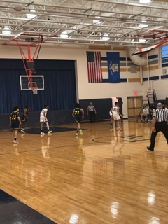
* 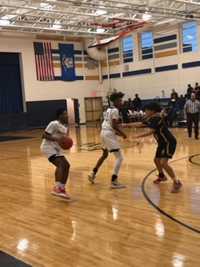
* The boys ended the season with a loss to Lyman Memorial in a tremendous game, 57-55. Thank you, Coach Lombardo, for leading the boys to the playoffs! The boy’s team should be proud to have been a basket away from the next round. The boys team demonstrated composure, respect and positive sportsmanship. It was an incredible season!!!
* 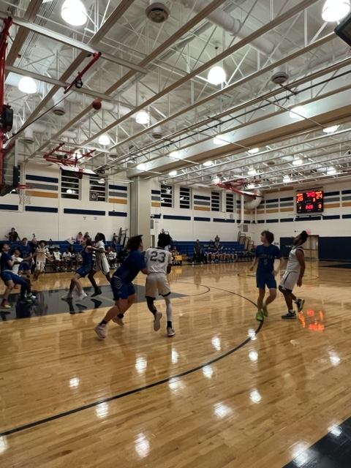
* 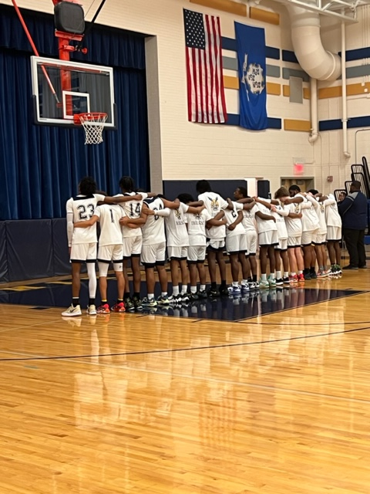
* 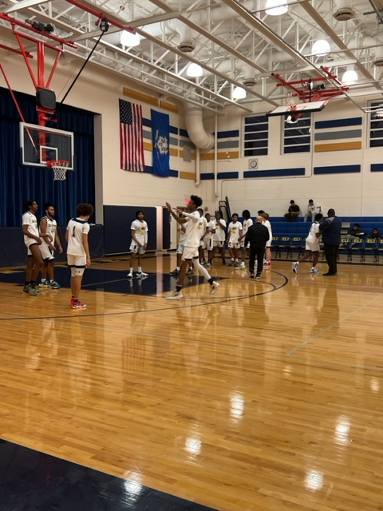
* The following is our March SEL message provided by Mrs. Becton, school social worker. SEL4US and Urban Assembly is inviting schools and communities around the world to celebrate March 10, 2023, the 4th annual Social Emotional Day (SEL) Day. This year's theme is Uplifting Hearts, Connecting Minds. Let's uplift our hearts and minds but showing compassion to ourselves and others. Compassion is bringing awareness to the suffering of ourselves (self-compassion) and others. It is the unconditional acceptance or focusing on the potential all people have for good. If we recognize the good, then when stress and conflict arise, compassion comes in, and guides us in self-regulating for positive outcomes.
* Follow us on the Eli Whitney Tech Instagram page. <https://www.instagram.com/eli_whitney_tech/>
* Follow us on the Facebook group. <https://www.facebook.com/WhitneyTech>
* **Daily attendance** is important as it prepares you for professionalism in the workplace or college. Chronic attendance occurs when you have 2 or more absences in a month. Achieving ten unexcused absences places you in the chronic absentee category and **may lead to credit denial**. Communication is important for all absences, notes should be submitted as well. Contact the Dean of Students with questions or concerns,   
  Mr. LeSieur, [chris.lesieur@cttech.org](mailto:chris.lesieur@cttech.org)
* As the Eli Whitney students have been extremely cooperative in the educational process, we have had numerous situations with student disagreements. As mentioned before and in the handbook, **fighting is not an acceptable form of disagreement**. Also, students should not carry knives, pepper spray, or any facsimile weapons. Communicate with the school counselors, teachers, administration, or SRO if aware of a potential issue or if a student needs to talk to someone.
* **If you see something, say something. A physical altercation or possession of the aforementioned can lead to out-of-school suspension, expulsion, and/or arrest.**

* **Dress code remains the same, no crocs, midriffs, or pants with holes. Pajamas should not be worn. The attire must be appropriate. Once again, IDs must be worn at all times.**
* 
* Cell phones may be used at the discretion of the teachers in class. **Don’t be distracted!** Recording of other students and adults is not permitted. We will be reviewing the policy to reduce the interruption of learning time.
* As we have transitioned into the WINTER season, if we need to cancel or delay school we will announce school closures in ParentSquare, and post on the following TV stations, CH3-WFSB, CH 61 Fox, CH8 WTNH, and CH30 WNBC.

Let’s work together to make Eli Whitney the best and safest school for trade and college preparation! Have a safe and great week!

Best regards,

Mr. DiNatale  
*Principal*

